AMAD Project 1 Milestone 2

For milestone 2 I focused on creating my calendar view. I used a collection view to easily create the grid in which the days of the month will be displayed. I also was able to use functions within Calendar, Date, and DateComponents that allowed me to get accurate information about how many days in each month and what day of the week each month started on. After getting the days to show up I also was able create buttons within the section header that allowed be to switch months. The label in the header also displayed the month that was being shown in the collection view. Whenever the user skips to the next or previous month the collection view is redrawn to display the correct month.

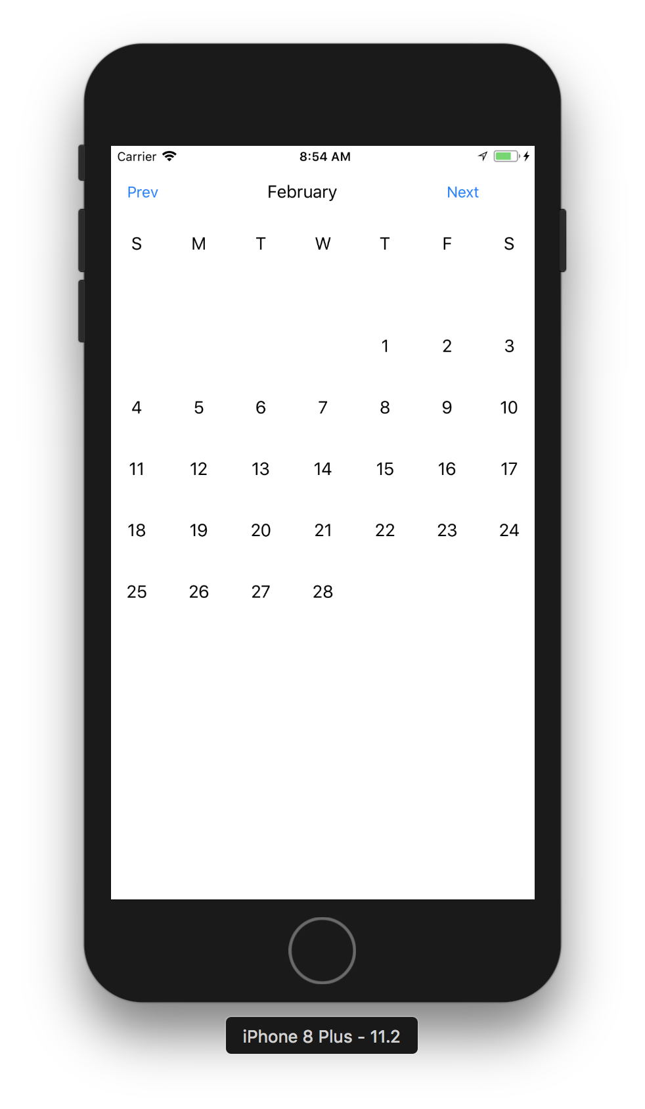

I also worked on a mockup of what the screen that asked the user what information they wanted to enter for a particular day. I incorporated the simple and circular design that I used in my previous skin care app.

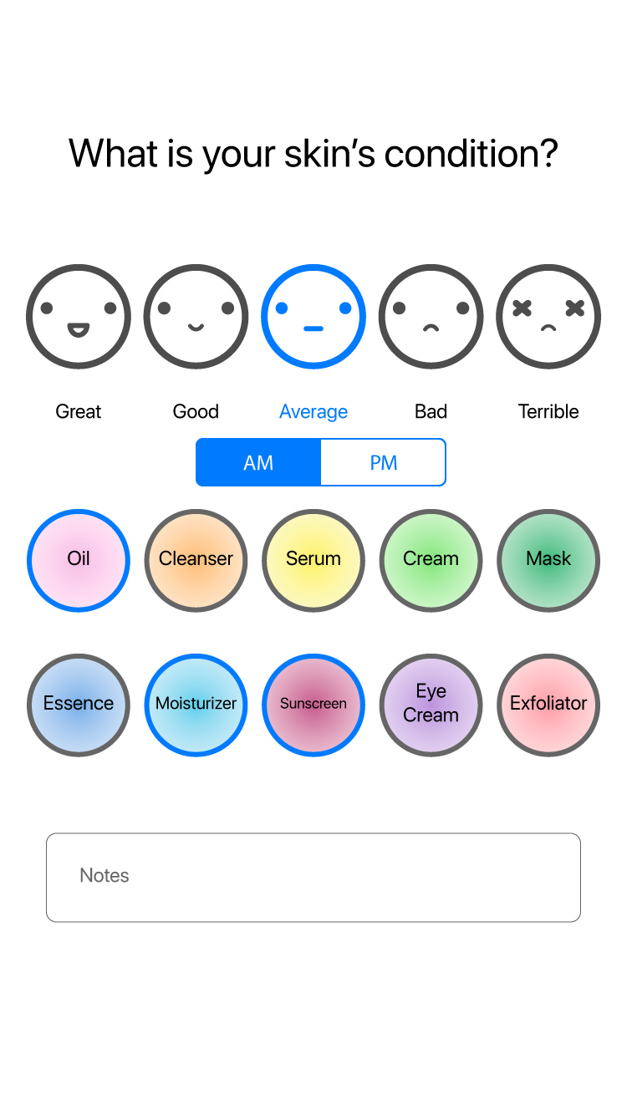

Pseudocode

User selects day

User enter data

Day passed to enterData view

User selects skin condition, steps, enters notes, AM/PM

Create Day object

Set day.condition, day.steps, day.notes day.time

Save data in firebase

Back to monthly view

Access information from firebase

Redraw collection view to reflect new information

User accessed day with data

Table view of entries

Add entry 🡪 repeat user enter data

Click on entry 🡪 Edit data

Go to enterDataView

Access firebase data

Populate buttons/selections with firebase data

User makes changes

Save data in firebase

Back to monthly view

Redraw collection view